1. **Prototype**

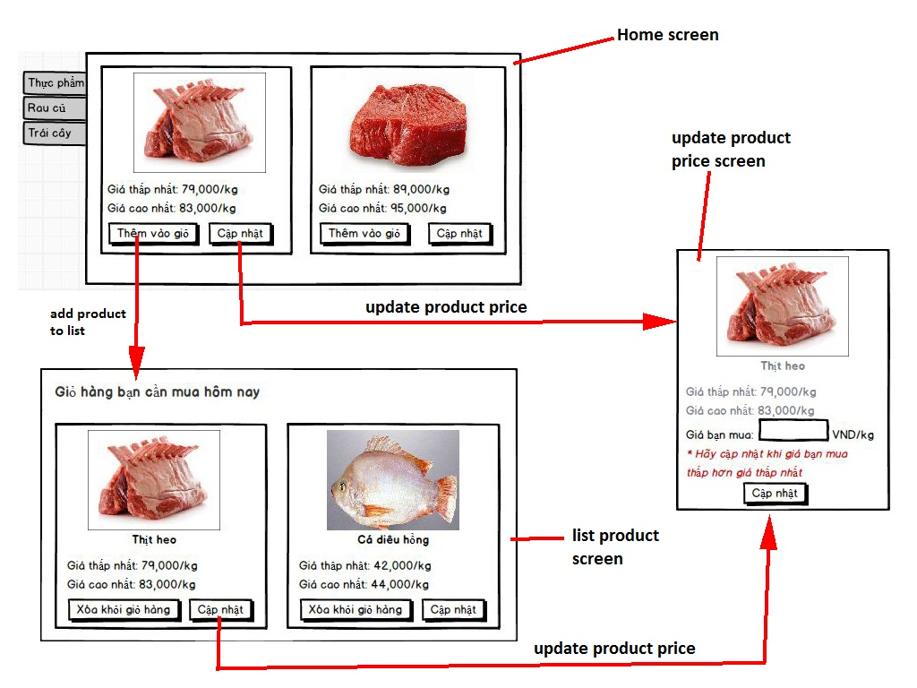

Tại (địa điểm nào?)

Nơi mua gần nhất?

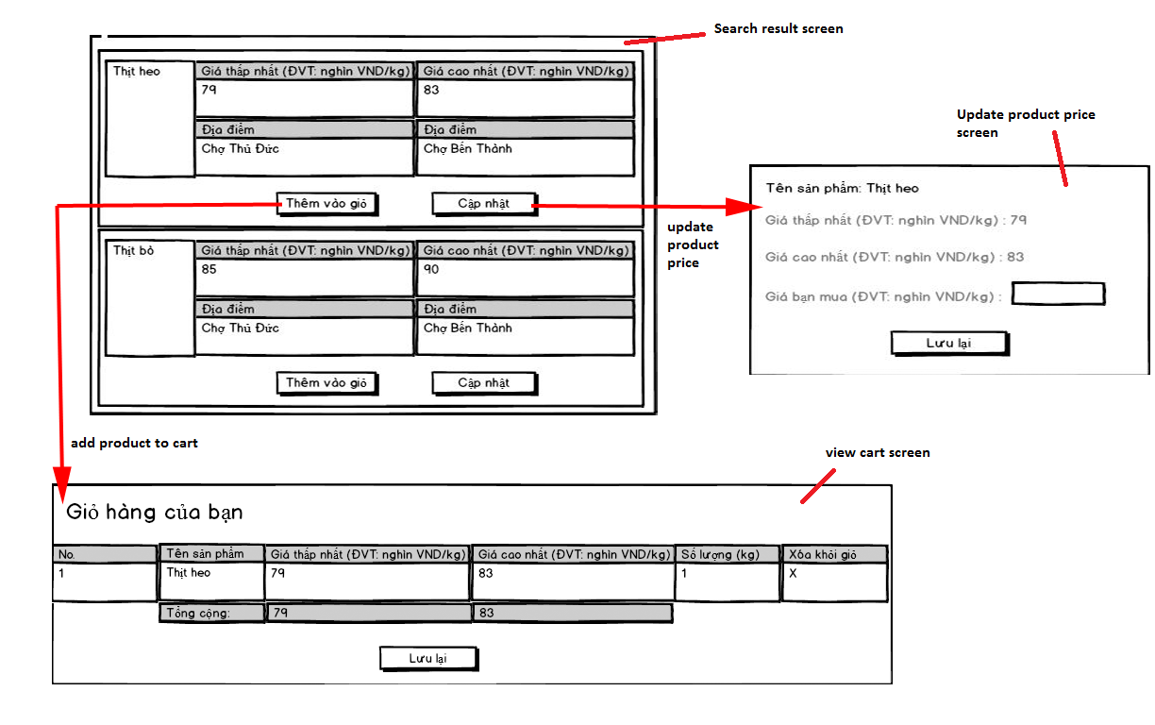

1. **Use case diagram**
   1. Add product to cart



|  |  |  |  |  |
| --- | --- | --- | --- | --- |
| **USE CASE – MU001** | | | | |
| **Use-case No.** | MU001 | **Use-case Version** | | 2.0 |
| **Use-case Name** | Add product to cart | | | |
| **Author** | Dang Huu Hoang | | | |
| **Date** | 11/01/2014 | **Priority** | High | |
| **Actor:** Guest/Member  **Summary:** This use case allows guest/member to add product to cart.  **Goal:** A product will be added to guest/member’s cart.  **Triggers:**   * Guest/Member can add product to cart after search product. * Guest/Member clicks on “**Thêm**” button on each result row.   **Pre-conditions:** N/A.  **Post-conditions:**  **Success:** The product will be added to cart.  **Fail:** Product will not be added to cart. Redirect to error page.  **Main Success Scenario**   |  |  |  | | --- | --- | --- | | **Step** | **Actor Action** | **System Response** | | 1 | Click “**Thêm**” button on result row. | * Check for the existence of the cart object in session [Exception 1]. * Add clicked product to cart [Alternative 1]. * Notify user. |   **Alternative Scenario:**   |  |  |  | | --- | --- | --- | | **No.** | **Actor Action** | **System Response** | | 1 | The product has existed in cart. | Update quantity of the product. |   **Exceptions:**   |  |  |  | | --- | --- | --- | | **No.** | **Actor Action** | **System Response** | | 1 | Session time out. | * Create new cart object in session. * Add clicked product to cart. * Notify user. |   **Relationships:** Search product.  **Business Rules:**   * Maximum quantity of each product is 10. * Maximum size of cart is 20. | | | | |

* 1. Save product history



|  |  |  |  |  |
| --- | --- | --- | --- | --- |
| **USE CASE – MU002** | | | | |
| **Use-case No.** | MU002 | **Use-case Version** | | 2.0 |
| **Use-case Name** | Save product history | | | |
| **Author** | Dang Huu Hoang | | | |
| **Date** | 17/01/2014 | **Priority** | High | |
| **Actor:** Member  **Summary:** This use case allows member to save cart.  **Goal:** The cart will be saved to member’s product history.  **Triggers:**   * Members want to save their cart. * Member clicks “**Lưu lại**” button.   **Pre-conditions:**   * User has logged in to the system with the role is “**member**”. * There is at least one product which was added to cart.   **Post-conditions:**  **Success:** Information of cart will be added to database. Show success message.  **Fail:** Show error message.  **Main Success Scenario**   |  |  |  | | --- | --- | --- | | **Step** | **Actor Action** | **System Response** | | 1 | The member clicks “**Lưu lại**” button on View cart page. | * Add new cart to database. * Show message “**Giỏ hàng đã được lưu thành công**” [Alternative 1], [Exception 1]. |   **Alternative Scenario:**   |  |  |  | | --- | --- | --- | | **No.** | **Actor Action** | **System Response** | | 1 | The cart has existed in database. | * Update cart to database. * Show message “**Giỏ hàng đã được lưu thành công**”. |   **Exceptions:**   |  |  |  | | --- | --- | --- | | **No.** | **Actor Action** | **System Response** | | 1 | Fail to insert to database. | * Show message “**Có lỗi xảy ra. Vui lòng thử lại sau**”. |   **Relationships:** Add product to cart, View cart.  **Business Rules:**   * The insert time of the cart is current time. * Save product name only, not quantity and price. | | | | |

* 1. Propose product price



|  |  |  |  |  |
| --- | --- | --- | --- | --- |
| **USE CASE – MU003** | | | | |
| Use-case No. | MU003 | Use-case Version | | 2.0 |
| Use-case Name | Propose product price | | | |
| Author | Dang Huu Hoang | | | |
| Date | 11/01/2014 | Priority | High | |
| **Actor:** Member  **Summary:** This use case allows member to propose product price.  **Goal:** Insert new product price to database.  **Triggers:**   * Member wants to propose new product price. * Member clicks on “**Cập nhật**” button on each search result row.   **Pre-conditions:**   * User has logged in to the system with the role is “**member**”. * User used search function to find product.   **Post-conditions:**  **Success:** Propose product price will be inserted to database. Show success message.  **Fail:** Show error message.  Main Success Scenario   |  |  |  | | --- | --- | --- | | Step | Actor Action | System Response | | 1 | Click on “**Cập nhật**” button on each search result row. | Pop up a window with:   * Giá đề xuất: text box (number only, min length: 1, max length: 4), required. * Lưu lại: button | | 2 | Input proposed product price, click “Lưu lại” button. | Updates new product price to the database and show message “**Cảm ơn sự đóng góp của bạn**”. [Alternative 1; Exception 1, 2] |   **Alternative Scenario:**   |  |  |  | | --- | --- | --- | | **No.** | **Actor Action** | **System Response** | | 1 | Price is out of range. | Show message “**Cảm ơn sự đóng góp của bạn**”. |   **Exceptions:**   |  |  |  | | --- | --- | --- | | **No.** | **Actor Action** | **System Response** | | 1 | Price is not a positive number. | Show error “**Giá không phù hợp**”. | | 2 | Price’s length is not in range. | Show error “**Giá không phù hợp**”. |   **Relationships:** Login, search product.  **Business Rules:**   * Average price (avgPrice) = $\frac{minPrice+maxPrice}{2}$* Epsilon $(ε)$ is a number set by staff. $Range ∈[minPrice-ε×avgPrice, maxPrice+ε×avgPrice]$ | | | | |